**Holistic Observation of Students Assignment #1** Look at your students in a holistic way.

- Consider the classroom in the 4 aspects of the medicine wheel.

- Teacher candidates, are there students who have strengths in a particular quadrant and are there

students whose needs you will have to remember when planning?

- Compare your observations with your collaborating teacher.

- Child-centered.

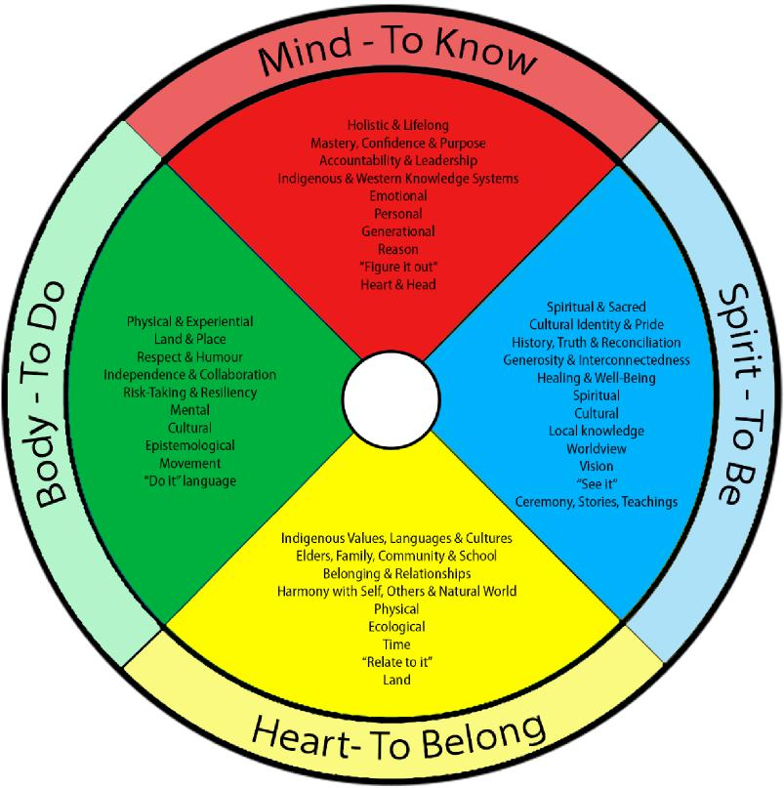

Adapted from:

- [https://cbe.ab.ca/about-us/policies-and-regulations/Documents/Indigenous-Education-Holistic-](https://cbe.ab.ca/about-us/policies-and-regulations/Documents/Indigenous-Education-Holistic-Lifelong-Learning-Framework.pdf)

[Lifelong-Learning-Framework.pdf](https://cbe.ab.ca/about-us/policies-and-regulations/Documents/Indigenous-Education-Holistic-Lifelong-Learning-Framework.pdf)

-<https://www.mycota.ca/pro-d-blog/2019/04/16/teaching-by-the-medicine-wheel>

**Holistic Observation of Students Assignment #1** Look at your students in a holistic way.

- Consider the classroom in the 4 aspects of the medicine wheel.

- Teacher candidates, are there students who have strengths in a particular quadrant and are there

students whose needs you will have to remember when planning?

- Compare your observations with your collaborating teacher.

- Child-centered.

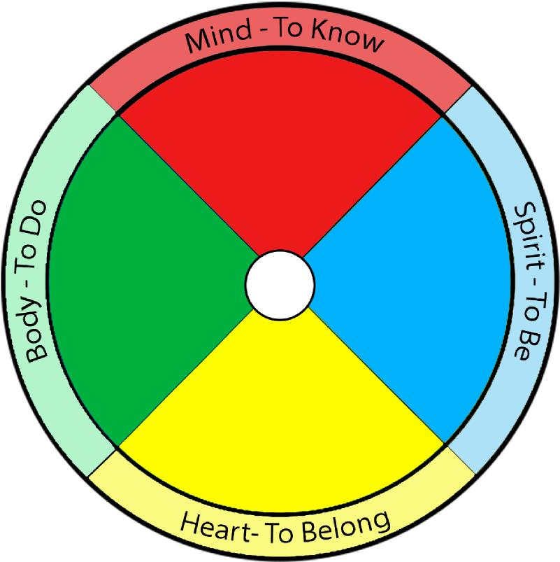

Adapted from:

- [https://cbe.ab.ca/about-us/policies-and-regulations/Documents/Indigenous-Education-Holistic-](https://cbe.ab.ca/about-us/policies-and-regulations/Documents/Indigenous-Education-Holistic-Lifelong-Learning-Framework.pdf)

[Lifelong-Learning-Framework.pdf](https://cbe.ab.ca/about-us/policies-and-regulations/Documents/Indigenous-Education-Holistic-Lifelong-Learning-Framework.pdf)

-<https://www.mycota.ca/pro-d-blog/2019/04/16/teaching-by-the-medicine-wheel>